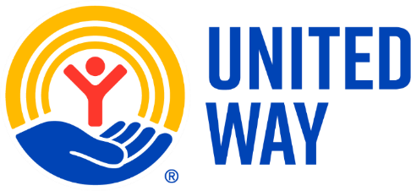
How to make your charitable donations through United Way:
Your organization’s 2025 campaign begins on 2/23/26. Donors can pledge using the campaign website until the campaign ends on 3/23/26. The United Way’s ePledge website is located at:
https://give.unitedwayswpa.org/PJD
The first page you will see is the Login Page.
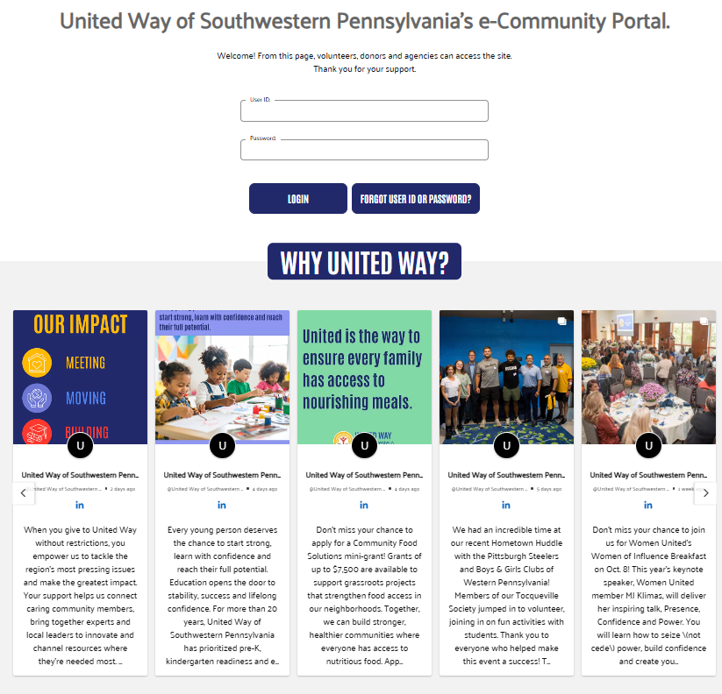

- User ID: PJD + first 3 letters of first name + first 3 letters of last name (ex. Joe Smith = PJDJoeSmi)
- Password: welcome2025
  - Notice: Passwords are case sensitive. Will require a Password Reset if generic.
- Click on the “LOGIN” button.

If you are having trouble signing in, click on the Forgot USERID and Password button or call Customer Service at 412-456-6824.

On the Forgot User ID and Password Reminder page please enter your email address. If you have registered before in our system you will receive a notification from us with User ID reminder and a link to reset your password.
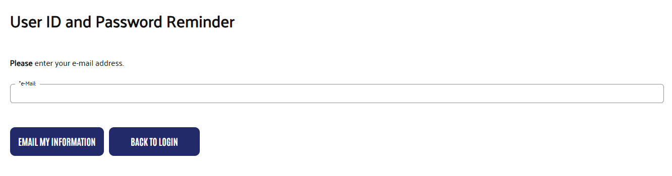

If this is your first time on the pledge site, please click on the link in the word here in the resulting message and proceed with the registration process.
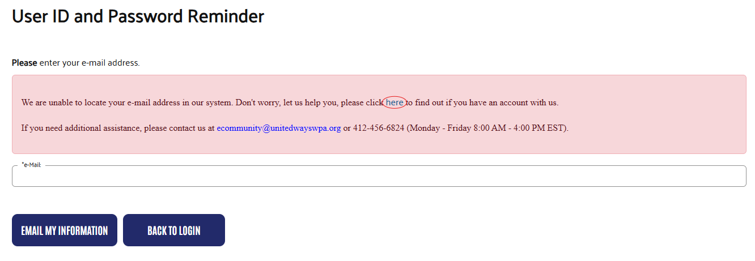

This will take you to the self-registration page where you will fill in some basic information to set up your account.

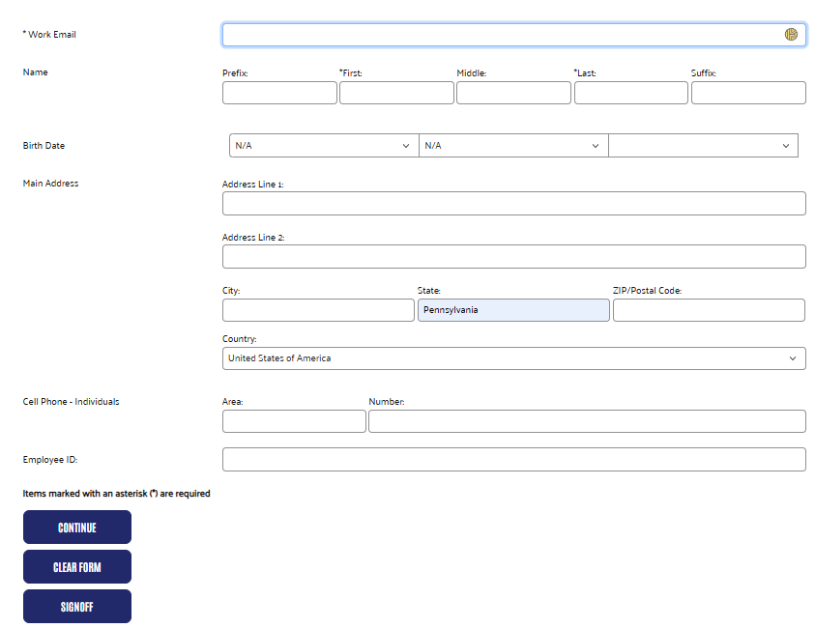

Once you log in, you will see the Welcome Page.
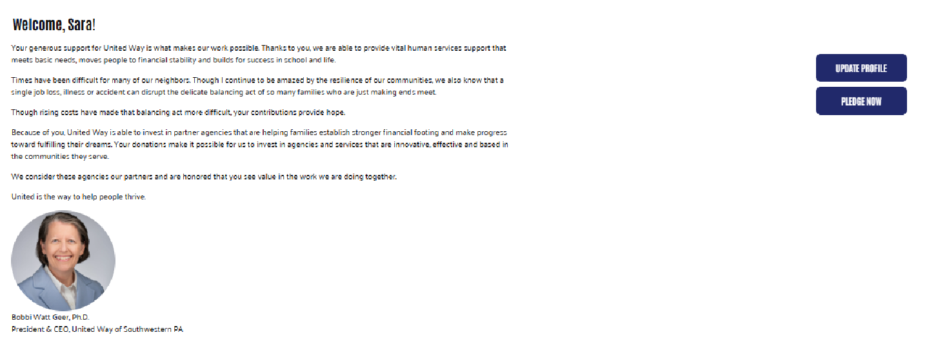

Click on ‘UPDATE PROFILE’ if needed
or
Click ‘PLEDGE NOW’ to continue.

If you click “Update Profile”, you will see the My Information Page. Please fill in as much up to date information as possible to ensure the best donor experience. Certain options when donating are only accessible through this provided information. Also, agencies like to have personalized acknowledgements sent via physical mail or email (if desired).
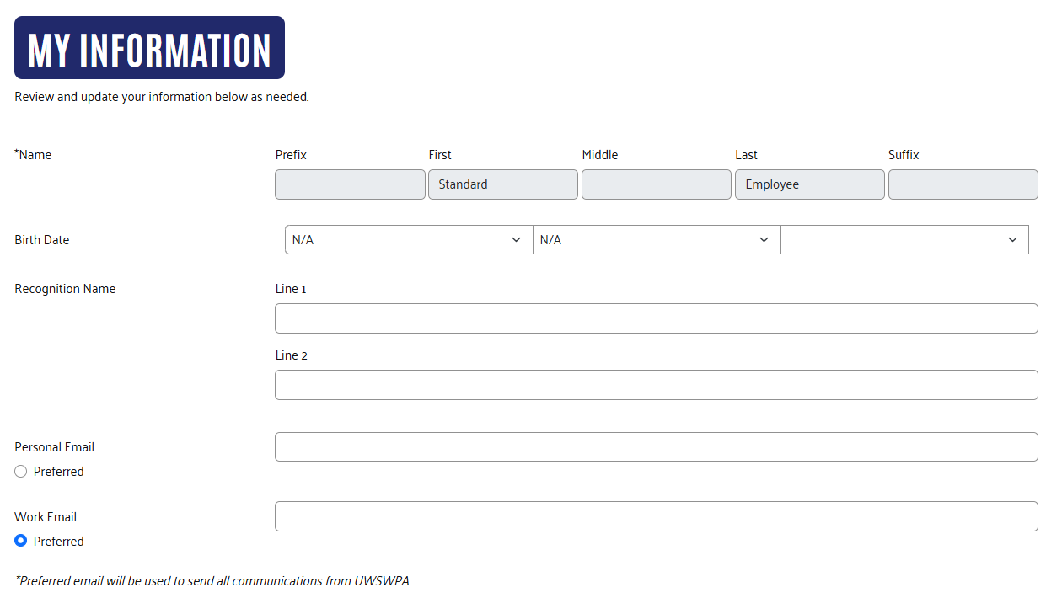
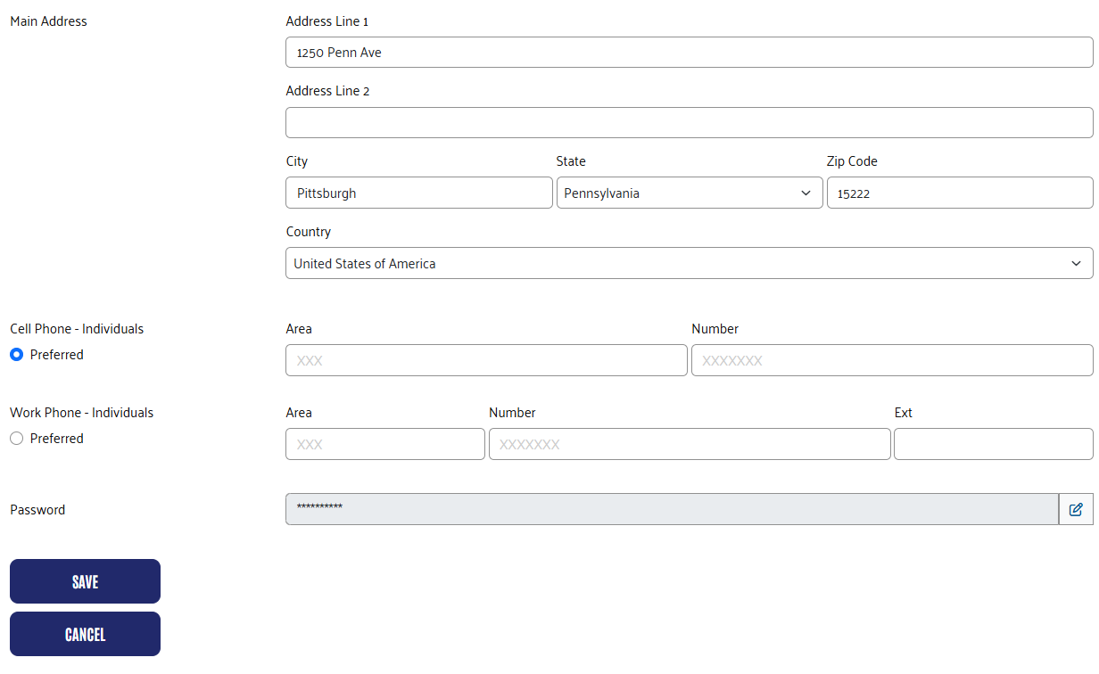

On the Pledge Page, you can select how you want to make your pledge and the amount of the pledge. If you gave in the previous year, any affinity group or giving level badge earned will appear at the top of the screen. The previous year’s donation will be displayed with options to increase your pledge and distribute among last year’s designations, keep everything the same as last year, or change your donation entirely.
If you choose to keep your donation the same as last year or choose one of the options to increase the amount, clicking Next will take you to the verification page.
If you wish to change your payment method or your designations, you must choose “Change my donation.”

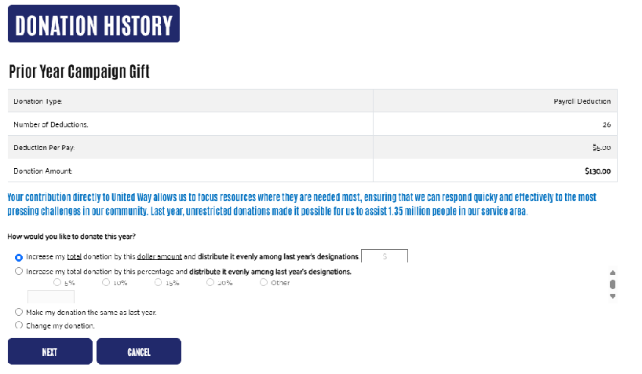

If you do not have a donation history from the previous year, or if you choose the “Change my donation” option, you will see options for pledge type, with a field below to enter pledge amount and payment frequency. If the current year’s pledge qualifies and United Way has relevant biographic information, related donor group options will be made available and badges will appear at the bottom of the screen.

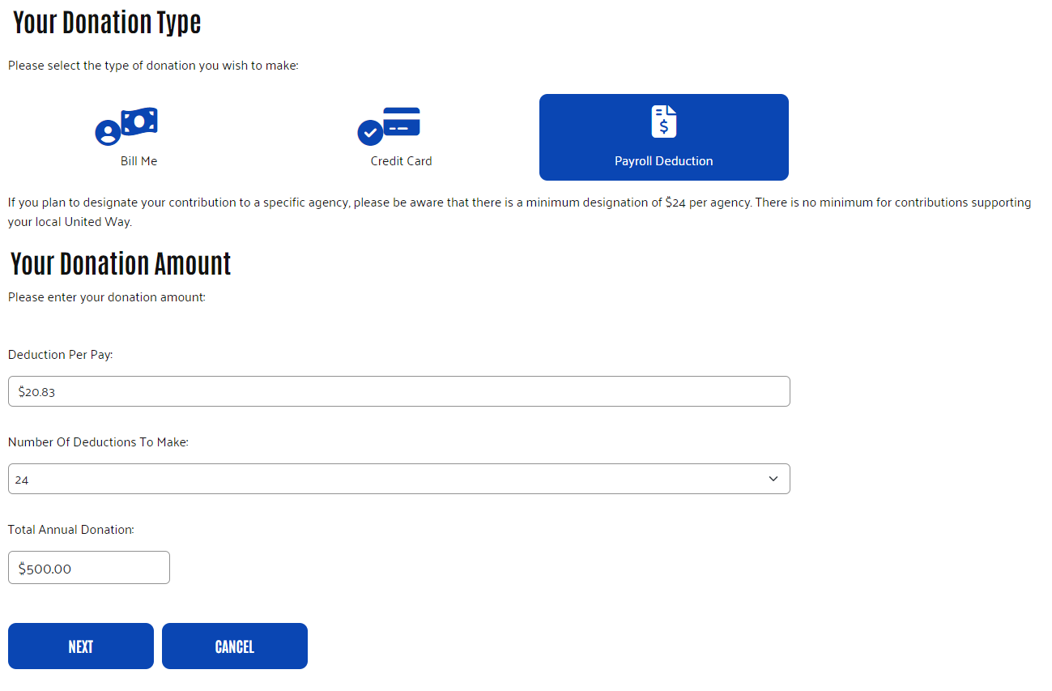

Once the pledge information is completed, click ‘NEXT.’

The Designation Page allows the you to select how you want your donation to support the community. Please consider donating directly to United Way. You can specify any (or all) of our investment priorities of meeting basic needs, moving to financial stability or building for success in school and life. Or you can select an approved agency.
Your prior year pledge will appear at the top of the page for reference, and prior designations will fill in automatically. You can adjust and update as you wish.
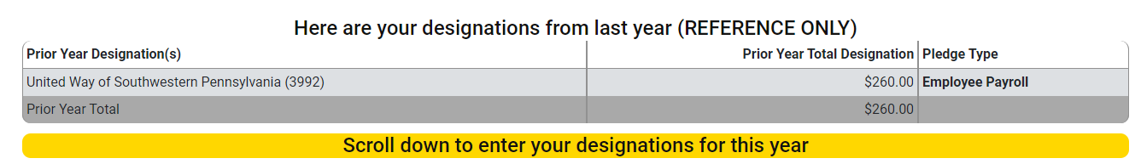
Your current pledge will display in a box near the top of the page that will move with you as you scroll down. The designated and undesignated totals will update as you enter your designations.
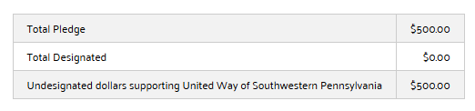
When you donate to United Way without restrictions, you give us the freedom to address the greatest community needs. You can also specify one of our investment priorities: meeting basic needs, moving to financial stability, or building for success in school and life. Simply enter the amount next to the fund you wish to support.
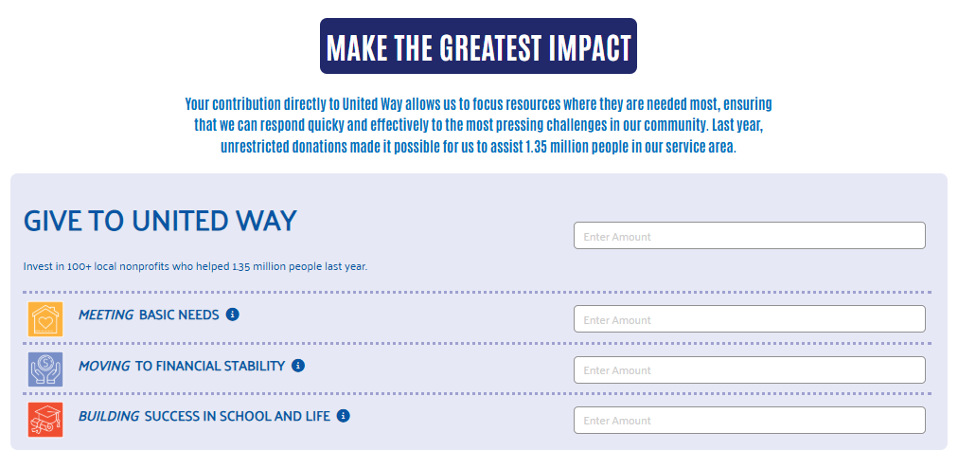

You can search for a specific approved agency using the Agency Search at the bottom of the page. Enter the agency’s name in the ‘Keyword Search’ field and click ‘SEARCH.’ A list of results will be displayed. You can then select your preferred agency from the list by clicking the ‘+’ symbol next to the agency’s name.
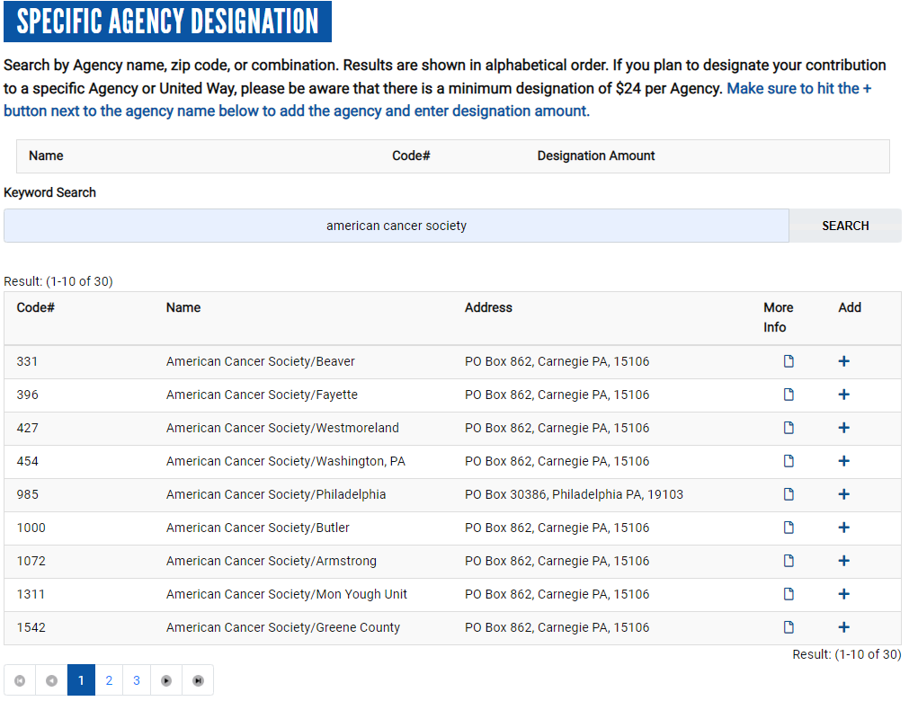

Once an agency is selected, you can designate all or a portion of your gift to the agency. You can select multiple agencies to support, if you pledge a minimum of $24 to each.

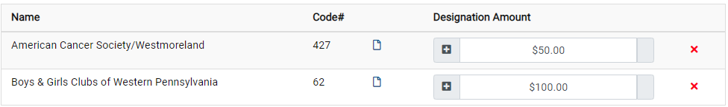

When designations details are complete, click ‘NEXT.’

The Verification Page gives you the opportunity to update your personal information and preferences, including membership in United Way’s donor groups (if relevant) and whether you wish to be acknowledged by any agencies you have designated. This page may include optional demographic information.

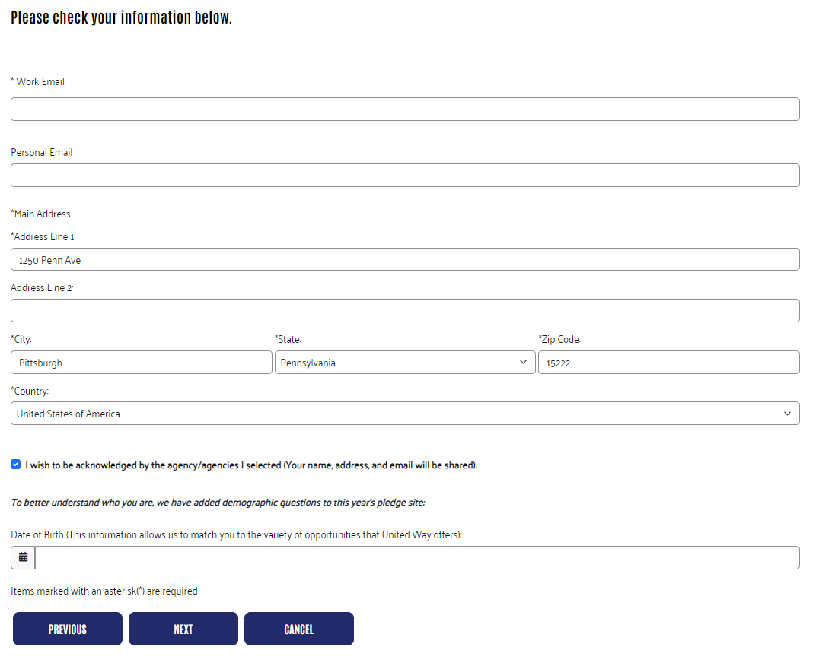
After information and preferences have been updated, click ‘NEXT’.

The Verification Page provides a review of your pledge, designations, and selections. From this page, you can return to a previous page to make changes or confirm your pledge information.
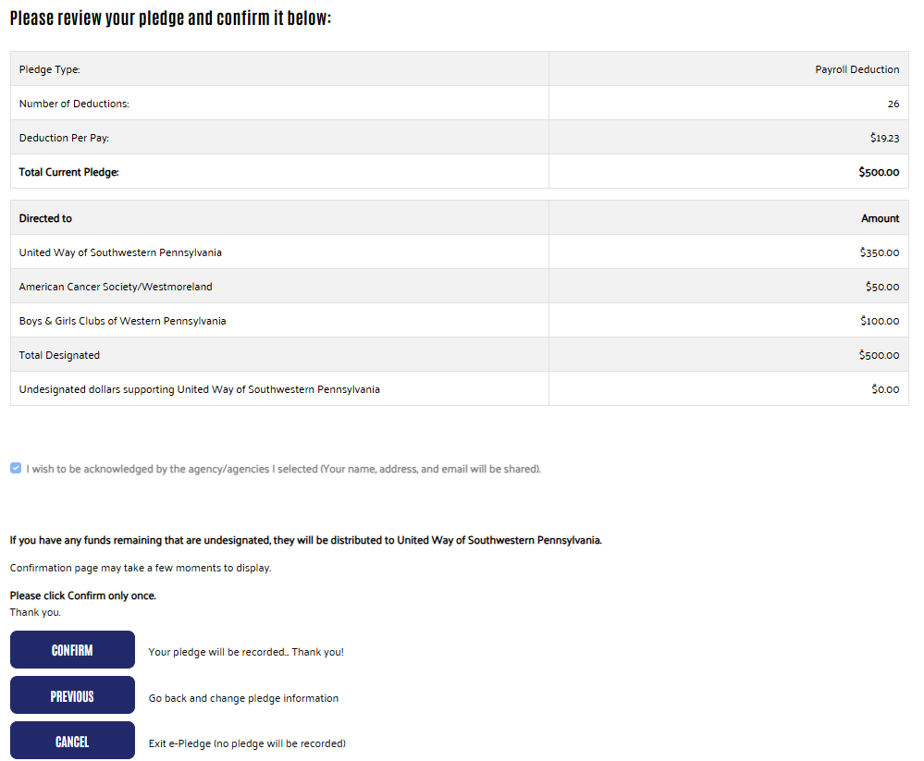

Once all details are accurate, click ‘CONFIRM’ to finalize your pledge.

You will be shown a confirmation screen and sent a confirmation email if an email address is provided.

